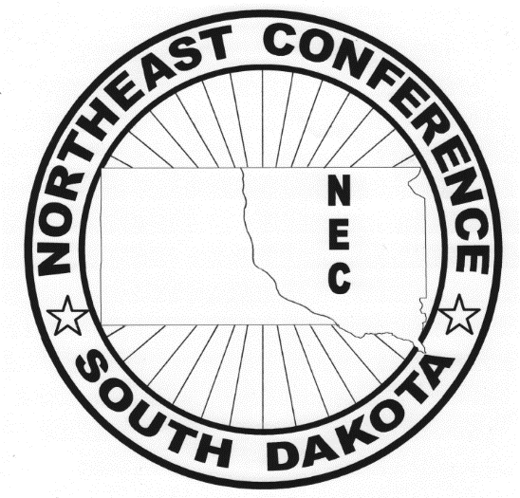
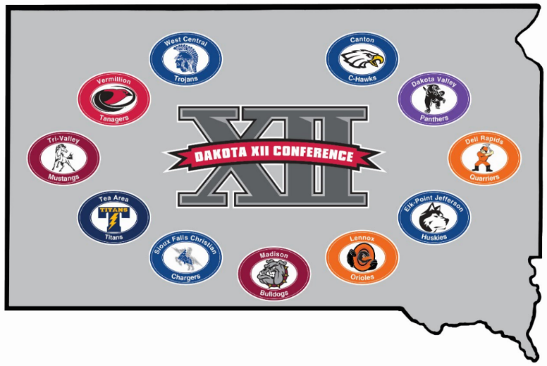
DAK-XII v. NEC CONFERENCE CLASH

SATURDAY, FEBRUARY 3RD, 2018 – MADISON, SD
GAMES WILL BE PLAYED AT MADISON HIGH SCHOOL
GIRLS PAIRINGS

Madison HS Aux. Gym |  |  | Madison HS Main Gym
10:45 AM | Tea Area vs. Deuel |  | 10:00 AM | Canton vs. Britton-Hecla
12:30 PM | Elk Point-Jefferson vs. Webster Area |  | 11:45 AM | Tri-Valley vs. Sisseton
2:15 PM | Sioux Falls Christian vs. Groton Area |  | 1:30 PM | Madison vs. Redfield/Doland
4:00 PM | Dell Rapids vs. Milbank |  | 3:15 PM | Vermillion vs. Castlewood
5:45 PM | Dakota Valley vs. Clark/Willow Lake |  | 5:00 PM | West Central vs. Aberdeen Roncalli
 |  |  | 6:45 PM | Lennox vs. Hamlin

ADULTS $7 – STUDENTS $4

