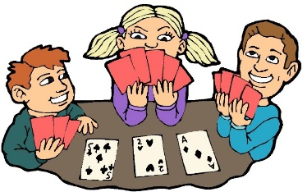
4th ANNUAL FAMILY MATH NIGHT

MONDAY MARCH 25, 2019
5:00-7:00 PM
ELEMENTARY COMMONS AREA
It’s no “JOKE”! Math is in the “Cards”! Follow “suit” and join us as we learn to ACE math with cards. (All students must be accompanied by an adult.) Door prizes will be given out as well as all families will take home A DECK OF CARDS! Walking tacos, ice cream cups and a drink will be provided for a FREE WILL DONATION. All proceeds will benefit OST.
**Students in OST will need to be picked up at the Upper Pod Multi-Purpose Room on this day.
Questions please contact Mrs. Weber or Mrs. Helvig at the school.
 ---------------------------------------------------------------------------------------------------------------------------------------------
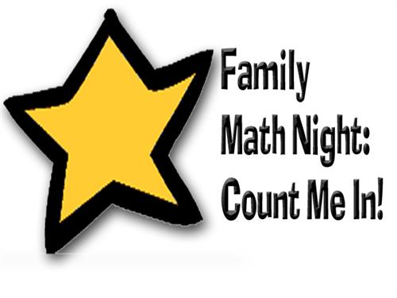
Please return by Wednesday, March 21st
Name:

Number of family members attending:
__________________

4th ANNUAL FAMILY MATH NIGHT

MONDAY MARCH 25, 2019
5:00-7:00 PM
ELEMENTARY COMMONS AREA
It’s no “JOKE”! Math is in the “Cards”! Follow “suit” and join us as we learn to ACE math with cards. (All students must be accompanied by an adult.) Door prizes will be given out as well as all families will take home A DECK OF CARDS! Walking tacos, ice cream cups and a drink will be provided for a FREE WILL DONATION. All proceeds will benefit OST.
**Students in OST will need to be picked up at the Upper Pod Multi-Purpose Room on this day.
Questions please contact Mrs. Weber or Mrs.Helvig at the school.
Thank you to Lori’s Pharmacy and Dairy Queen for their donations!
PLEASE RSVP BY:
MARCH 21, 2019

